**Chapter 1: Introduction to IoT**

**1.1) Identify the requirements for the real-world problems**

**Introduction to Internet of Things**

Internet of Things (IOT) is the networking of physical objects that contain electronics embedded within their architecture in order to communicate and sense interactions amongst each other or with respect to the external environment. In the upcoming years, IOT-based technology will offer advanced levels of services and practically change the way people lead their daily lives. Advancements in medicine, power, gene therapies, agriculture, smart cities, and smart homes are just a very few of the categorical examples where IOT is strongly established.

Over 9 billion Things (physical objects) are currently connected to the Internet. As of now, in the near future, this number is expected to rise to a whopping 20 billion.

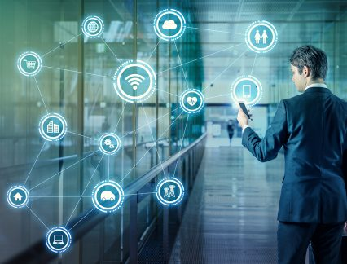

Figure 1.1: Introduction to IOT.

**There are four main components used in IOT:**

1. **Low-power embedded systems–**  
   Less battery consumption, high performance are the inverse factors play a significant role during the design of electronic systems.
2. **Cloud computing–**  
   Data collected through IOT devices is massive and this data has to be stored on a reliable storage server. This is where cloud computing comes into play. The data is processed and learned, giving more room for us to discover where things like electrical faults/errors are within the system.
3. **Availability of big data –**  
   We know that IOT relies heavily on sensors, especially real-time. As these electronic devices spread throughout every field, their usage is going to trigger a massive flux of big data.
4. **Networking-connection–**  
   In order to communicate, internet connectivity is a must where each physical object is represented by an IP address. However, there are only a limited number of addresses available according to the IP naming. Due to the growing number of devices, this naming system will not be feasible anymore. Therefore, researchers are looking for another alternative naming system to represent each physical object.

**There are two ways of building IOT:**

1. Form a separate internetwork including only physical objects.
2. Make the Internet ever more expansive, but this requires hard-core technologies such as rigorous cloud computing and rapid big data storage (expensive).

**IOT USAGE IN DEVICES**

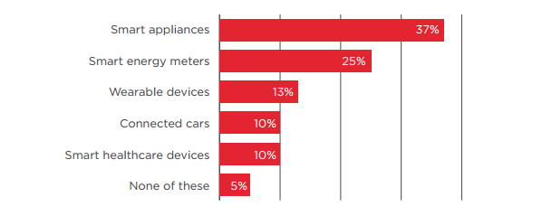

Figure 1.2: GSMA Report.

**Requirements of the real world solved by IOT**

1. **Ability to monitor security** of substations, as well as real-time data on electrical use, and report exceptions so they can be addressed in a timely manner. Ability to solve problems across silos in a utility where IT, Operations and Security don’t talk to each other. Facilitate communications about what’s important.
2. **Any information you need from a device** in order to perform a particular action. Examples provided:
   1. Re-closer on the distribution side of a power line that gets hit by lightening can be closed, checked and reopened by machine after reading the information on the site.
   2. Measure temperature and flow of a pipeline to ensure everything is working as expected or be notified is variances outside the norm are seen.
   3. Solar back-up to devices that may have power or battery issues.
3. **Ability to know how to fix your garage door** because the sensor can tell the company what’s wrong and they can tell you how to fix it. B2B example - a bio-lab is not aware of the volume of enzymes their clients still had on hand. If client ran out, they’d have to put a project on hold for a week or two while more enzymes we made and shipped. They now put one of our devices on every enzyme container so they know which scientist is using which enzyme and when supply is running low. Real-time stock updates enable new bio-lab to optimize the supply chain for their clients.
4. **Communication, collaboration, cohesion and unification of various objects.**Becoming more convenient and connected with the devices we use every day. How to collaborate with devices and work through technology.
5. **Streamlines efficiency and communication of information.**Sensors provide data all the time. Influences decisions by giving you real-time data. Sensors in stores and in manufacturing environments tell you exactly what’s going on and if something is out of the acceptable range you can correct it quickly. Emergency of smaller computers are enhancing communications. We’re taking commodity hardware and optimizing with sensors.
6. All technology starts as a novelty. Becomes a convenience. That’s where IOT is now. **Making it more convenient to control and monitor the 3D printer.** Not yet a pure utility (the end stage for a technology). Ultimately, going forward, things will be built with IOT as a core element, not a special feature. For us, the end point is the printer which can source content from the internet.
7. Industrial internet - **digitization can be applied to the decision making process.**Consumer and healthcare companies will have new apps with connected devices to help save lives and mitigate disasters (e.g., floods, earthquakes).
8. **All IOT solutions solve some problem** - some are smaller, some are bigger. It’s easy to make a lock to connect to the internet. We use cryptography, website and code so the lock doesn’t have to be connected to the internet. Our IOT is not connected to the internet, just the website. As such, the lock cannot be hacked.
9. **Simpler, less expensive home health monitoring** (e.g., scales, blood pressure) to prevent post-surgical events that require return visits to the hospital. Increase adoption and adherence to medication protocols. Opportunity to use data to predict what’s going to happen. Preventive and predictive healthcare.
10. A **connection between humans and computers.** Use Amazon Echo to get all his songs from Amazon Prime and play on demand. Links home management like garage door, lights and HVAC.
11. **Energy saving.** A lot of devices are left on overnight, or longer. Interact with buildings and homes to save energy.
12. **Health devices connected to smart phones diagnose health conditions quickly.** You can take pictures and obtain diagnostics to share with health professionals around the world. Enables the collection and sharing of data in an affordable way. Allows inventors to think about use cases. Digitizes the power grid. Play with how energy is being served. Every device in your house will give you an energy profile. Enterprises will benefit from the digitization of devices and enable the next wave of digitization.
13. Know people that are in the building and **have visibility into what’s going on**. We monitor several thousand conference rooms at Microsoft’s campus to determine if they’re occupied, if A/V is working, what devices people are using, scheduling, booking. We collect data in the cloud to analyze uptime and failure rates. We proactively monitor to see what’s going on. We have statistics about room use and occupancy that will inform and influence the design of the conference rooms on Microsoft’s new campus. In homes, our hub connects all light switches, thermostats, keypads, security system and provides statistics to the cloud so the homeowner can view a dashboard to see how the home is being used. Occupancy use data. We’ll be able to use predictive analytics to make suggestions on how to change the real-time lighting, temp, etc. for your home. Many more touch points - switches, mobile phone, devices, reporting to the cloud versus a single thermostat (Nest) - provide more data for analysis.
14. **Changed the brand cycle.**It used to be 18 to 24 months. Now you must be monitoring social networks to hear what customers are saying and address their concerns or leverage what they are seeing as most beneficial. As John Chambers says, 40% of companies won’t exist in 10 years if they’re not listening to, and responding to the needs of, their customers.
15. **Asset management** - how to engage information to run control systems. Understand the health of the asset producing the work. Know the health and diagnostics of the machine to reduce down time and proactively provide maintenance. Ability to tie the supply chain into the process and provide information back to manufacturing thus reducing costs and expense.
16. **Manufacturers using crowd sourcing to build out their manufacturing floor.** Consumer wireless routers are only secure for a couple of years. Consumer products have a short life expectancy with consumers. Whereas industrial companies need to have an ongoing relationship with their customers since they have service contract and the products often need ongoing service. In healthcare alone IOT has already made incredible contributions saving lives, giving doctors the ability to see a spectrum of health conditions across a large number of people. It will enable more self-care by patients. Clinical trials are now being based on data received from IOT devices thus accelerating time to market. Industrial is incredibly influential because of the buy in from so many big players like IBM, Cisco and GE.
17. **Enables people to try a new approach.** Automate and control things remotely in ways you couldn’t before. Opportunities differ by industry but every industry has many opportunities.
18. We’re at the very early stages but making progress every day. **Getting basic, real-time visibility into places where we haven’t had it before.** For example, we can see a pipeline every half mile and look at KPIs for variances rather than have a human out driving the line and taking measurements. We’ve figured out how to put predictive diagnostics in place. We’re creating a digital twin on the product based on historical performance so we can identify potential needs. IOT provides visibility and reliability where we’ve never had it in the past.

**1.2) Applications of IoT**

**1. IOT Applications – Wearable’s**

Wearable technology is a hallmark of IOT applications and probably is one of the earliest industries to have deployed the IOT at its service. We happen to see Fit Bits, heart rate monitors and smart watches everywhere these days.

One of the lesser-known wearable includes the Guardian glucose monitoring device. The device is developed to aid people suffering from diabetes. It detects glucose levels in the body, using a tiny electrode called glucose sensor placed under the skin and relays the information via Radio Frequency to a monitoring device.

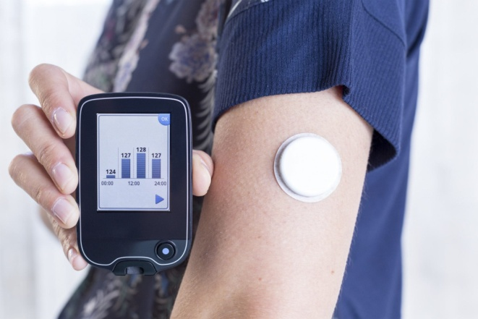

**Figure 1.3:** Guardian glucose monitoring device.

## ****2. IOT Applications – Smart Home Applications****

When we talk about IOT Applications, Smart Homes are probably the first thing that we think of. The best example I can think of here is Jarvis, the AI home automation employed by Mark Zuckerberg. There is also Allen Pan’s Home Automation System where functions in the house are actuated by use of a string of musical notes. The following video could give you a better idea.

## ****3. IOT Applications – Health Care****

IOT applications can turn reactive medical-based systems into proactive wellness-based systems. The resources that current medical research uses, lack critical real-world information. It mostly uses leftover data, controlled environments, and volunteers for medical examination. IOT opens ways to a sea of valuable data through analysis, real-time field data, and testing. The Internet of Things also improves the current devices in power, precision, and availability. IOT focuses on creating systems rather than just equipment. Here’s how an IOT-enabled care device works.

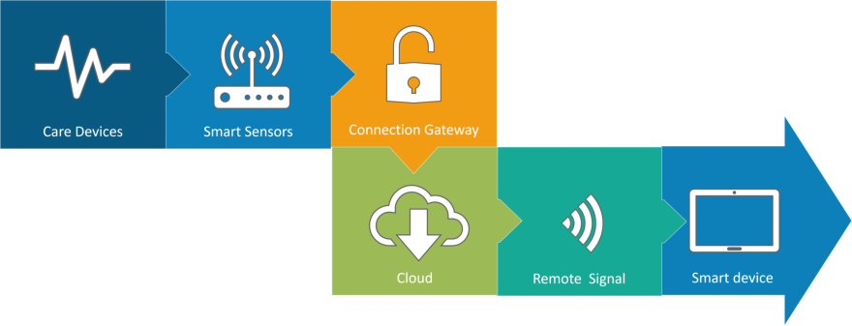

Figure 1.4: IOT enabled care device.

**4. IOT Applications – Smart Cities**

By now I assume, most of you must have heard about the term **Smart City**. The hypothesis of the optimized traffic system as I mentioned earlier, is one of the many aspects that constitute a smart city. The thing about the smart city concept is that it’s very specific to a city. The problems faced in Mumbai are very different than those in Delhi. The problems in Hong Kong are different from New York. Even global issues, like finite clean drinking water, deteriorating air quality and increasing urban density, occur in different intensities across cities. Hence, they affect each city differently. The Government and engineers can use IOT to analyze the often-complex factors of town planning specific to each city. The use of IOT applications can aid in areas like water management, waste control, and emergencies.

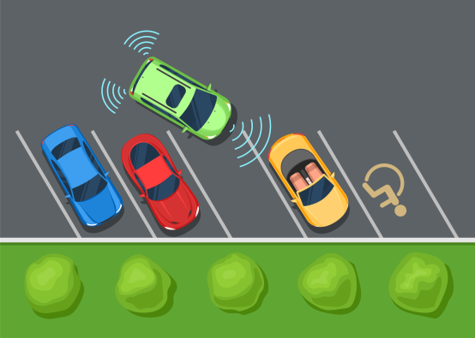

Figure 1.5: IOT based Smart City.

## ****5. IOT Applications – Agriculture****

Statistics estimate the ever-growing world population to reach nearly 10 billion by the year 2050. To feed such a massive population one needs to marry agriculture to technology and obtain best results. There are numerous possibilities in this field. One of them is the **Smart Greenhouse**. A greenhouse farming technique enhances the yield of crops by controlling environmental parameters. However, manual handling results in production loss, energy loss, and labor cost, making the process less effective. A greenhouse with embedded devices not only makes it easier to be monitored but also, enables us to control the climate inside it. Sensors measure different parameters according to the plant requirement and send it to the cloud. It, then, processes the data and applies a control action. 

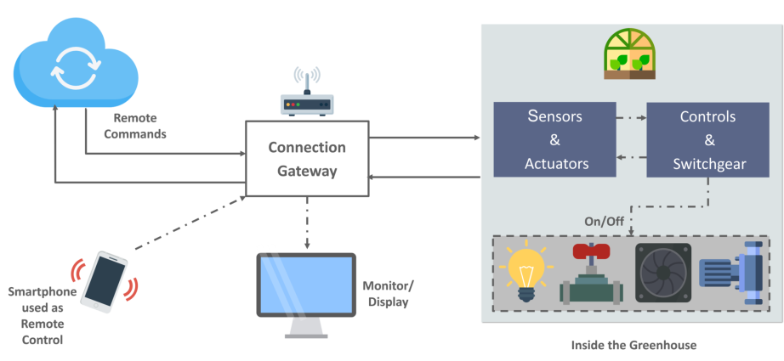

Figure 1.6: Smart Greenhouse.

**6. IOT Applications – Industrial Automation**

This is one of the fields where both faster developments, as well as the quality of products, are the critical factors for a higher Return on Investment. With IOT Applications, one could even re-engineer products and their packaging to deliver better performance in both cost and customer experience. IOT here can prove to be game changing with solutions for all the following domains in its arsenal.

* **Factory Digitalization**
* **Product flow Monitoring**
* **Inventory Management**
* **Safety and Security**
* **Quality Control**
* **Packaging optimization**
* **Logistics and Supply Chain Optimization**

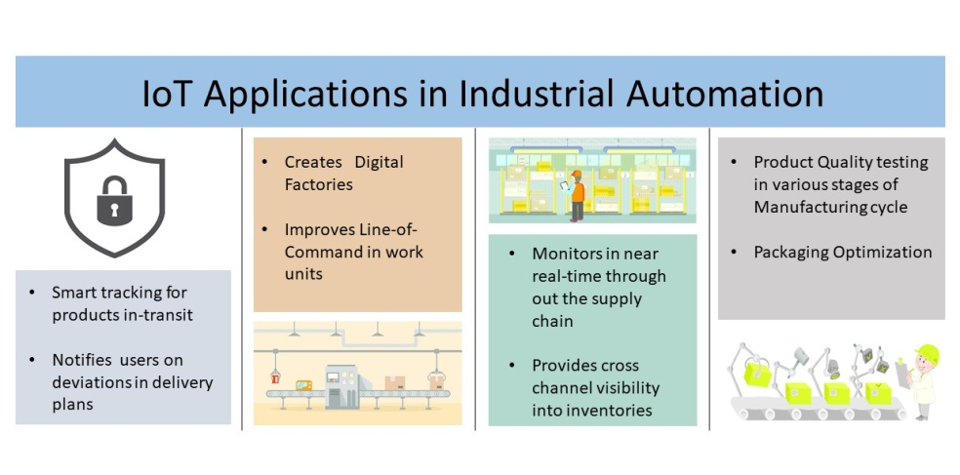

Figure 1.7: Industrial Automation.